Public subnet 1 in AZ us-east-1a within the VPC created in previous step:

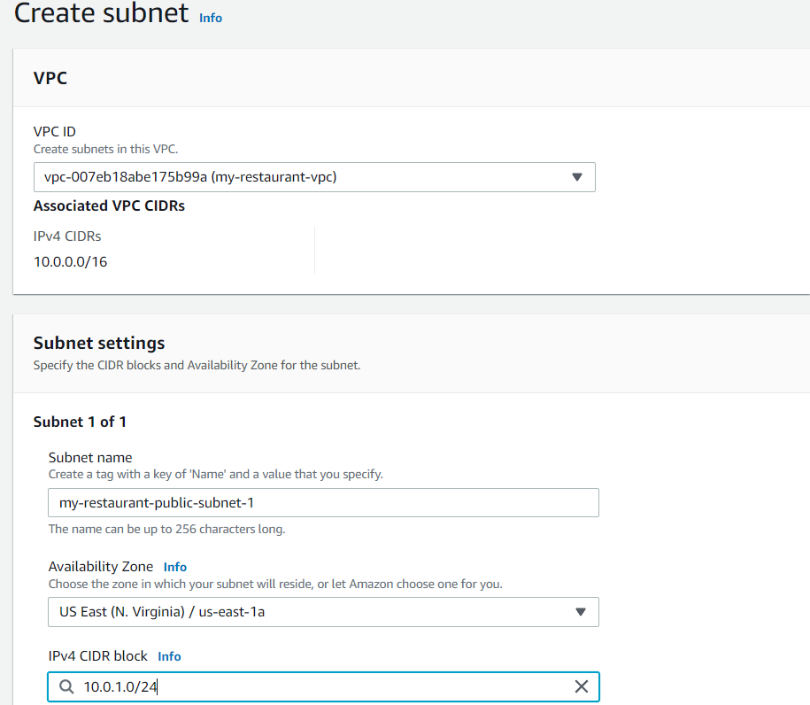

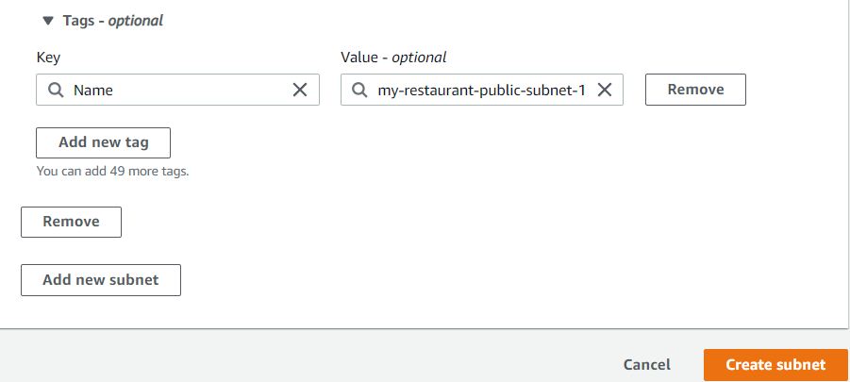

Public subnet 2 in AZ us-east-1b within the VPC created in previous step:

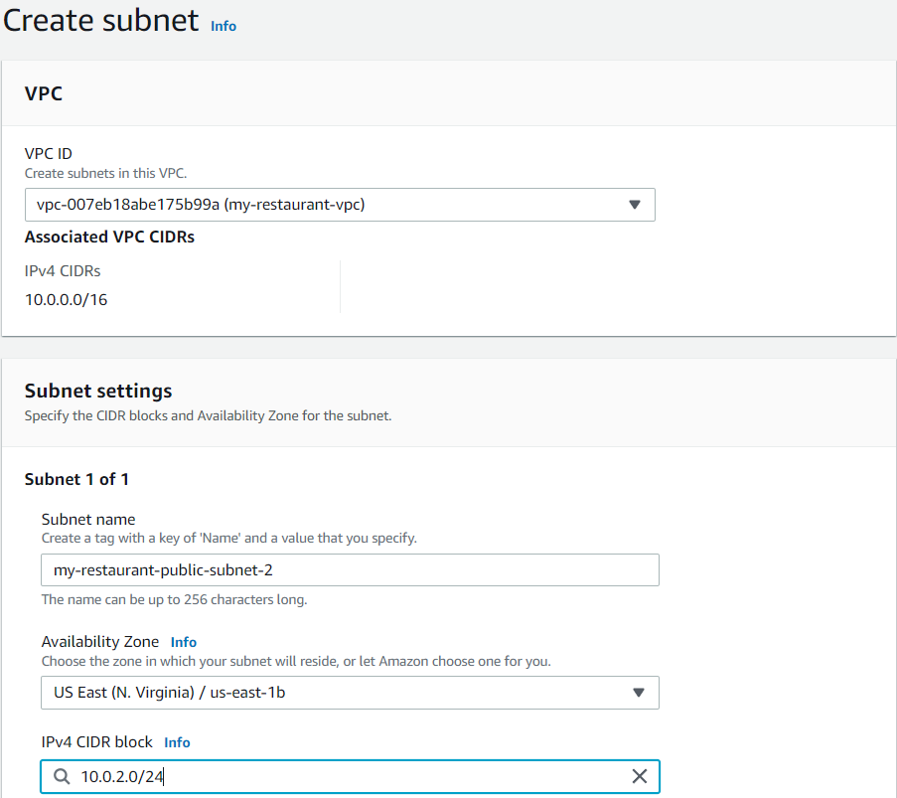

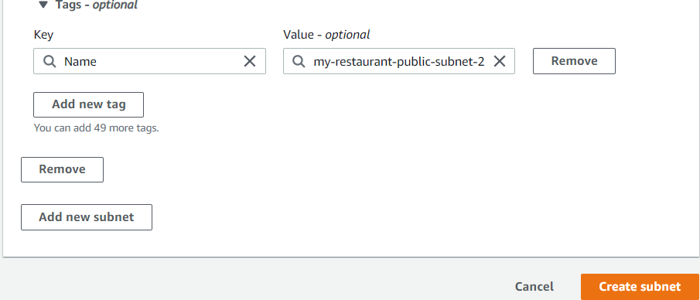

Private subnet 1 in AZ us-east-1a within the VPC created in previous step:

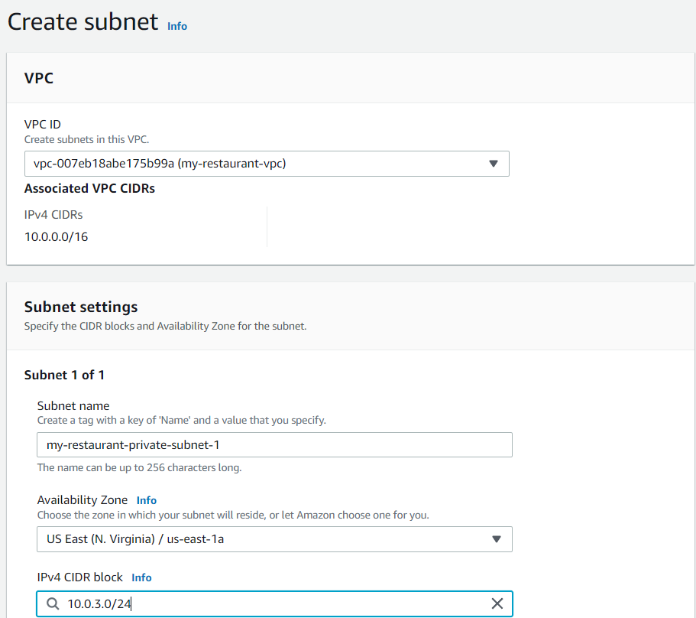

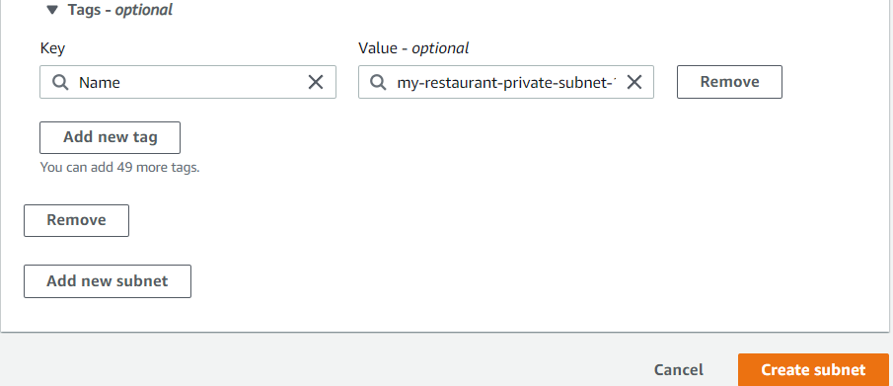

Private subnet 2 in AZ us-east-1b within the VPC created in previous step:

